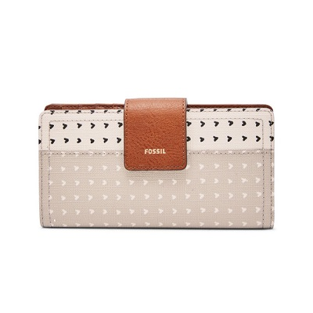

Logan RFID Tab Clutch

PRODUCT DETAILS

**Silhouette: Tab Clutch**

**Exterior Material: 100% PVC/Polyurethane Trim**

**Interior Details: 1 ID Window, 4 Bill Compartments, 12 Credit Card Slots**

**Measurements: 6.75"L x 0.75"W x 3.5"H**

**Warranty: 1 Year Limited**